Linux Commands

1. Basic Command: These are fundamental commands for interacting with the system and files.
- `man`: Used to display the manual pages of other commands.

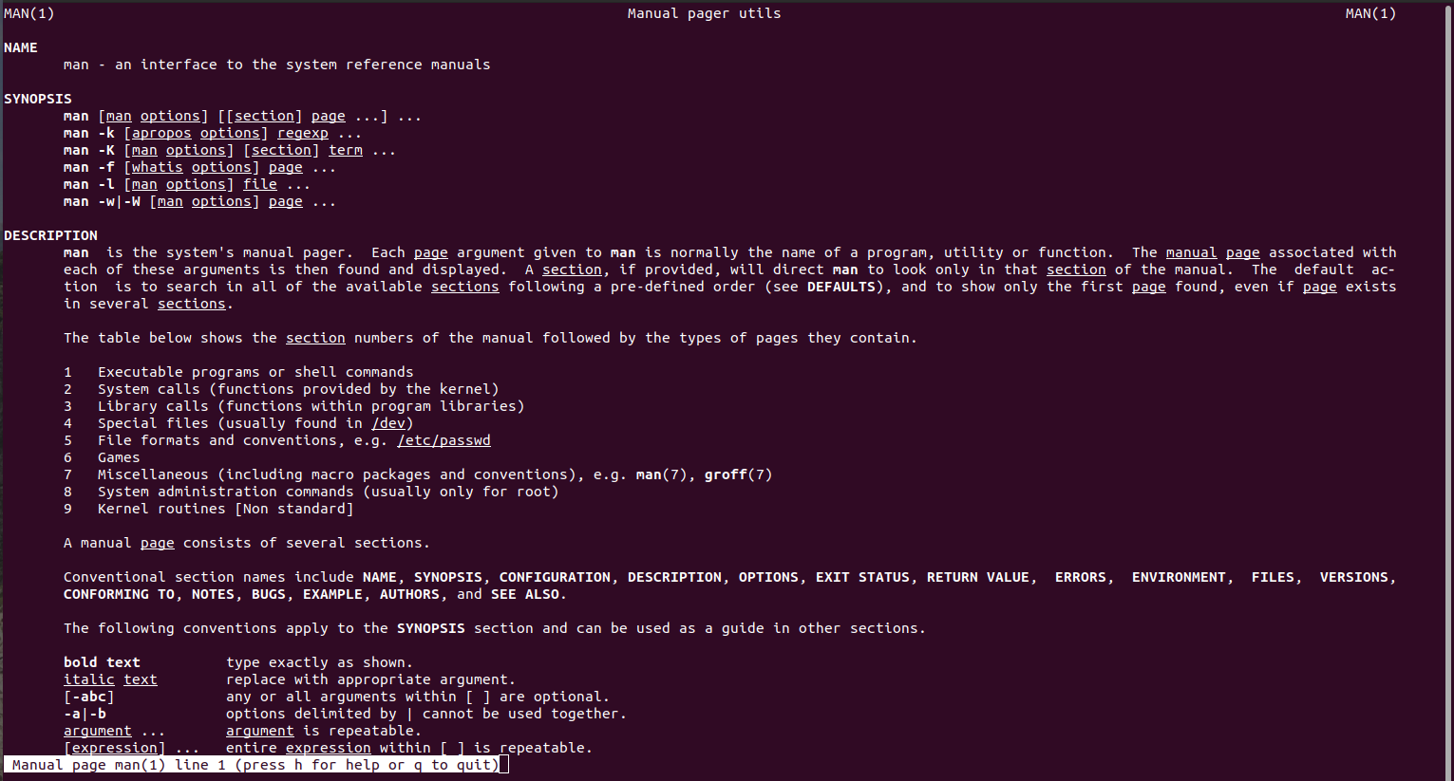

2.File and Directory Management: Commands related to managing files and directories.
- `ls`: Lists directory contents.

- `echo`: Prints arguments to the standard output.

- `read`: Reads a line from standard input.

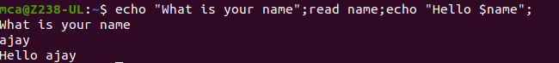

3. File Viewing and Manipulation: Commands for viewing and manipulating file contents.
- `more`, `less`: Used to view text files one screen at a time.

- `cat`: Concatenates and displays files.

4. Navigation and Searching: Commands for navigating the file system and searching for files.
- `cd`: Changes the current directory.
- `mkdir`: Creates directories.
- `pwd`: Prints the current working directory.
- `find`: Searches for files in a directory hierarchy.

5. File Operation: Commands for moving, copying, renaming, and archiving files.
- `mv`: Moves files or directories.
- `cp`: Copies files or directories.
- `rm`: Removes files or directories.
- `tar`: Archives files into a tarball.

6. Text Processing: Commands for manipulating text data.
- `wc`: Prints the number of newlines, words, and bytes in files.
- `cut`: Cuts out sections from each line of files.
- `paste`: Merges lines of files.

7. File Display: Commands for displaying the beginning or end of files and for searching within files.
- `head`: Outputs the first part of files.
- `tail`: Outputs the last part of files.
- `grep`: Searches for patterns in files.
- `expr`: Evaluates expressions.

8. Permissions and Ownership: Commands for managing file permissions and ownership.
- `chmod`: Changes file mode bits (permissions).
- `chown`: Changes file owner and group.

9. Redirections & Piping: Techniques for controlling input and output streams and chaining commands together.

10. User Management: Commands for managing user accounts and passwords.
- `useradd`: Adds a new user to the system.
- `usermod`: Modifies a user account.
- `userdel`: Deletes a user account.
- `passwd`: Changes user passwords.

11. System Monitoring: Commands for monitoring system resources and processes.
- `df`: Displays disk space usage.
- `top`: Displays Linux processes.
- `ps`: Reports a snapshot of current processes.

12. Secure Shell: Commands for secure network communication and file copying.
- `ssh`: Connects to a remote machine securely.
- `scp`: Securely copies files between hosts.
- `ssh-keygen`: Generates SSH keys.
- `ssh-copy-id`: Copies SSH keys to a remote host for passwordless logins.

